Production Readiness Policy

LLM Gateway - Production Readiness Policy (Simplified - Tier Based)

Objective
To define fallback and production-readiness policies for teams using LLMs via LLM Gateway, enabling high availability, cost efficiency, and reliability.

Tier Definitions

Tier 1: Production-Critical
- Use Case: Customer-facing, business-critical, or high-scale systems
- Qualification (any one):
- 100,000 requests/week
- $10 spend/week ( We will validate this and change this accordingly )
- Business-critical or customer-facing workloads.
- Production related task.
- Requirements:
- Minimum 2 model providers configured so that if one provider fails the upcoming requests shall be routed to another provider.
- Fallback model must be configurable so in case of some failures from the first model, fallback shall be done to another decided model.
- Proactive alerting mandatory (alert on failure rate, latency, model unavailability and other important factors).
- Minimum 2x of weekly spend on each provider account shall be maintained.
- Production prioritization keys used (no POC/test keys).

Tier 2: Pre-Production/POC at Scale
- Use Case: Internal tools or near-production use cases
- Qualification:
  - 20,000 requests/week
  - $5 < spend/week $10 ( We will validate this and change this accordingly )
- Requirements:
  - At least two providers for each model.
  - Alerting recommended (warn on failure/high response time)
  - At least 1.5x the weekly spend.
  - Can use POC-tier keys but must define rate limits
- Fallback Strategy:
  - Same provider preferred (e.g., gpt-4 ➝ gpt-4-mini)
  - Tolerate short cooldowns, auto-retry supported

Tier 3: Experimental / Evaluation
- Not suitable for production workloads
- Use Case: Prompt testing, model evaluation, low volume exploration
- Qualification:
  - < 20,000 requests/week
  - < $5 spend/week ( We will validate this and change this accordingly )
- Requirements:
  - No fallback required
  - Alerting optional
  - Use with minimal impact expectations
- Fallback Strategy:
  - Not enforced

Operational Notes
- Load balancing should be defined in LLM Gateway model specific.
- All Tier 1/Tier 2 apps must have Support for multiple providers, Alerting and Fallback enabled and Rotation between providers should be validated weekly after validating the model's performance.
Approval Required : Vicky Sarkar / Amit Agarwal

How to Use LLM Gateway

📘 LLM Gateway API Usage Guide
Base URL: https://imllm.intermesh.net
Authentication: Access Key (Bearer Token)
Model Access: Provided model names only (e.g., qwen/qwen3-32b)

🔐 Authentication
Each request must include an Authorization header with your personal access key.

Example:

Authorization: Bearer <your-access-key>

🔧 Making Requests
LLM Gateway follows the OpenAI-compatible REST API format. This means you can use standard OpenAI clients or tools with just the base URL and your key.

Endpoint:
POST /v1/chat/completions

Headers:

Content-Type: application/json
Authorization: Bearer <your-access-key>

Sample Request:

curl https://imllm.intermesh.net/v1/chat/completions \
-H "Authorization: Bearer sk-xxx" \
-H "Content-Type: application/json" \
-d '{
"model": "openrouter/qwen/qwen3-32b",
"messages": [
{"role": "user", "content": "Explain quantum computing in simple terms"}
]
}'

Supported Parameters

Parameter | Description
model | The exact model name you were provided access to (e.g., openrouter/qwen/qwen3-32b)
messages | List of messages with role as user, assistant, or system
temperature | (Optional) Controls randomness (default: 1.0)
top_p | (Optional) Controls diversity via nucleus sampling (default: 1.0)
max_tokens | (Optional) Max number of tokens to generate in the reply
stream | (Optional) Set to true for streamed responses

For more information or swagger please visit https://imllm.intermesh.net

💻 Example in Python

import openai

openai.api_key = "sk-xxx" // LLM Gateway access key
openai.base_url = "https://imllm.intermesh.net/v1"

response = openai.ChatCompletion.create(
model="qwen/qwen3-32b",
messages=[
{"role": "user", "content": "Summarize the book Sapiens in 5 sentences."}
]
)

print(response['choices'][0]['message']['content'])

Streamed Response Example (Curl)

curl https://imllm.intermesh.net/v1/chat/completions \
-H "Authorization: Bearer sk-xxx" \ // LLM Gateway access key
-H "Content-Type: application/json" \
-d '{
"model": "qwen/qwen3-32b",
"messages": [{"role": "user", "content": "Write a short poem on rain"}],
"stream": true
}'

❓FAQs

1. How do I know which models I can use?
You will be explicitly granted access to specific models. Use only those in the "model" parameter.

2. Can I use OpenAI SDKs?
Yes. Just set:
openai.api_base = "https://imllm.intermesh.net/v1"
And the key will be the LLM Gateway provided key.

3. Can I use it from Postman or REST clients?
Absolutely. Just make sure to:
- Set the Authorization header
- Use POST method
- Send JSON body with required parameters

4. Can the same used with n-8-n
Absolutely. Just make sure to follow the below steps.
Step 1: Add OpenAI Chat Model as Language Models

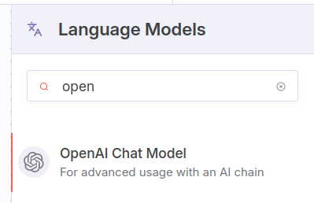

Step2: Create New Credentials
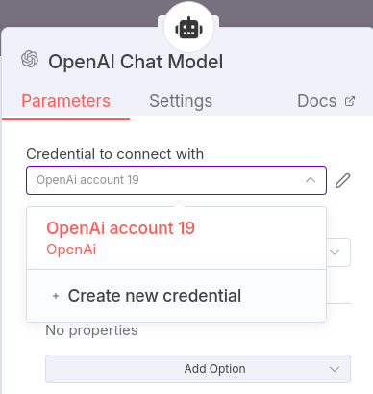

Step3: Set the base URL as https://imllm.intermesh.net and API Key as provided API key.
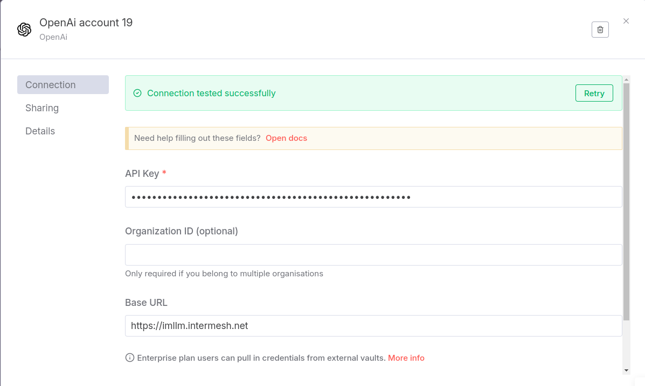

SOP - NFA
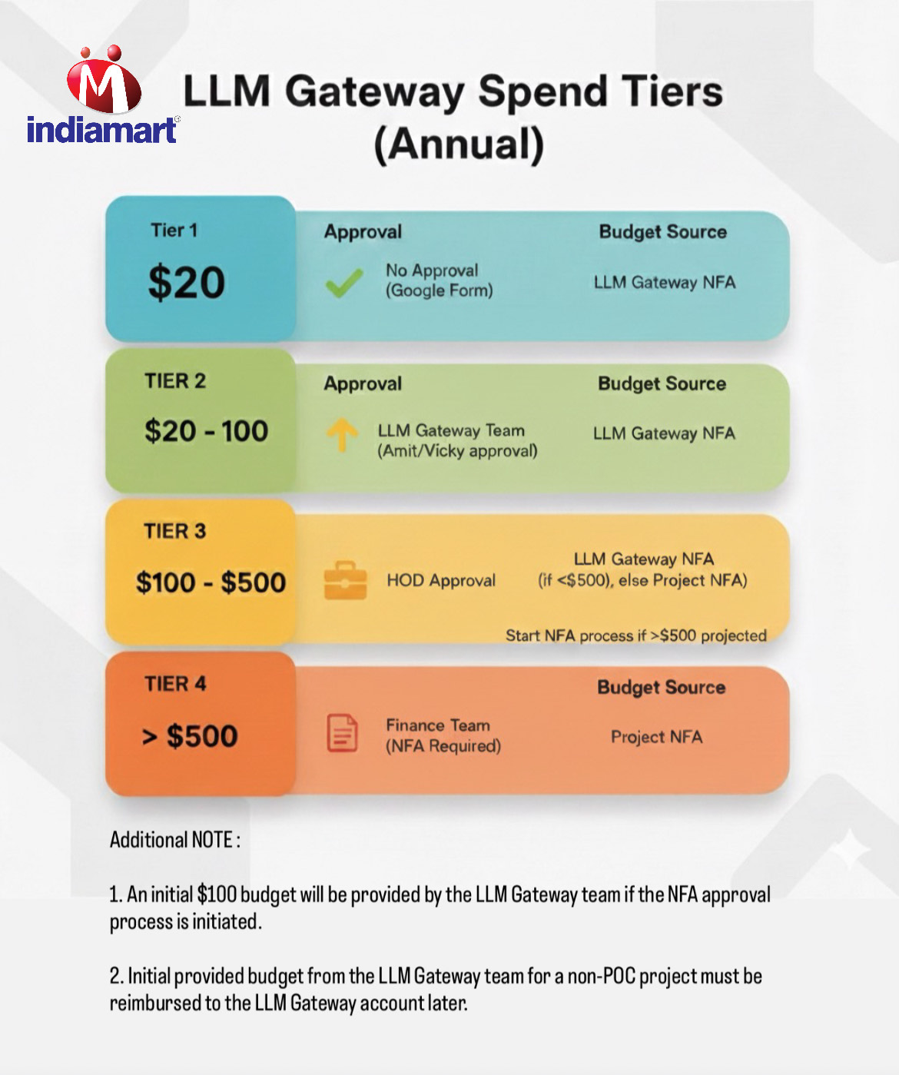

SOP - Access Management for Central LLM Gateway

SOP: Access Management for Central LLM Gateway.

Version | 1.0
Owner | DevOPS/Gateway
Effective Date | 25th June 2025
Audience | Team IndiaMART

Purpose
This SOP defines a secure process for requesting, issuing, and managing access to the LiteLLM-based Central LLM Gateway. It ensures controlled use, centralized cost tracking, model-level restrictions, and full auditability.

Tools/Platforms
- LLM Gateway: https://imllm.intermesh.net
- Chat UI: https://imassist.intermesh.net
- VS Code Integration: Continue.dev extension
- Monitoring UI: https://imllm.intermesh.net/ui
- Support Contact: llm-gateway@indiamart.com
1. Requesting for Access for POC use case
Just Fill the Google Form and get the key in a minute with below default values :
TPM - 30,000
RPM - 50
Budget 20 USD
Expiry 30 days

2. Requesting for Access for non POC use case
- To open a ticket in SOA-Image,API Gateway bucket
- Share the information asked in the provided sheet. LLM Gateway-Prerequisites for Key Provisioning
- Get the Manager’s Approval Done.
- To provide HOD approval if the budget is more than 100 USD or production use case.
- For a total Budget more than USD 500 limit requires an independently approved NFA from the respective team.
- Get the final budget approval from Amit Agarwal / Vicky Sarkar.

2. Distributing API Keys & Access
- Keys shared privately via email or Hangout DM.
- Each key: user/team scoped, with expiry.
- Endpoint: https://imllm.intermesh.net/v1/chat/completions
- Authorization: Bearer <access-key>

3. Monitoring & Expiry
- Keys are time-bound at issuance.
- DevOps tracks usage through /ui:
- Token consumption
- Latency & error metrics
- Models accessed

4. Renewal & Revocation

Renewal: Submit new request before expiry.

5. Access Control Matrix

Role | Access Type | Key Type | Expiry Default
AI Engineer | API + Developer UI access | Team API Key | 30 days
Product Lead | UI-only (Chat Interface) | Login | N/A
POC | Limited API access | Temporary Key | 30 days
Admin | Full access + key control | Master API Key | Permanent

6. NFA Requirement Process
- The LLM Gateway team will maintain a standing NFA approved by the Finance team for the financial year.
- Any team with annual spend expected to exceed $500 must obtain a separate NFA from the Finance team.
- While raising the request, the provider must be mentioned as "LLM Gateway" in the NFA application.
- At the end of each month, spend by the team will be deducted from the budget approved in the NFA obtained by the product team.

6. Do’s & Don’ts
✅ Do:
- Store keys securely (e.g., ENV, Vault)
- Rotate keys used in apps
- Use only approved models
❌ Don’t:
- Commit keys to code or repos
- Use unapproved models
- Misuse the provided keys

7. Support & Escalation
For issues, model access, outages, or misuse:
- Email:llm-gateway@indiamart.com

8. Review & Audit
- Monthly usage audits by DevOps
- Weekly & Monthly Adoption Report to be sent.
- SOP reviewed half-early

Acknowledgement
Team Manager signs off confirming understanding and compliance:
Name: Vicky Sarkar

